A SCATHING OPINION PIECE OF THE TIMES WE LIVE IN - WITH AUSTRALIA AT THE FOREFRONT
D Denham B Arch June 2023
“AS THE ELIZABETHAN AGE FADES , THE MORONIC AGE THRIVES UNABATED” ( Or , What you needed to know about Climate Change , but the Morons are terrified you’ll find out )
A little harsh ? You be the judge . Having survived three quarters of a century , I despair at the ignorance which abounds throughout this country and around the planet it seems . I no longer recognise the brave new world which emerged from the freedoms and dramatic changes which we generated through the 60s and 70s . Our music remains like a forlorn echo , but I could weep with how the extraordinary words from such luminaries as Martin Luther King lie buried under a putrid , Woke sludge . However at the core of this ignorance , lies the rhetoric spat out for thirty odd years from semi-Morons who know no better – virtuous hypocrites like King Charles , or the Clintons and Bonos of this world . Hypocrites because of their virtuous lecturing versus their massive Carbon footprints . However there are also those who although qualified , genuinely believe their own focussed and often selective science . I will forgive them , if they are prepared to openly and honestly explore the historically accepted broader science as well , but more importantly, the reality of current observation which seems to contradict their narrow viewpoint . However , those who have the qualifications and the responsibility to ascertain the truth , but who follow and promote fraudulent agendas through warped ideology and outright greed , and are usually exposed by the staggering money trail which follows them , now they are to be despised . They are the True Morons . Just behind them trot their lapdogs within Mainstream Media , who blindly follow the dogma without engaging their brains . Not all mind you , but way too many .
And what is all of this vitriol referring to ? Only the absurd assertion that one of the three compounds essential for life on this planet , Carbon Dioxide , is a pollutant , resulting in our suicidal Lemming-like rush into energy poverty , and the death of Capitalism with all of its associated aspirations and freedoms disappearing before our very eyes . But what is scary , is that this utterly flawed and corrupt ideological agenda has been delivered to the masses encased in science free rhetoric , with the true agenda often in plain sight but totally ignored by most in the Media . Take for example this report titled ”The First Global Revolution” published by the Club of Rome in 1991 , (The UN , Rockefellers , JP Morgan , Rothschilds etc ) , which contains the following little gem : “In Searching for a new enemy to unite us , we came up with the idea that pollution , the threat of global warming , water shortages , famine and the like would fit the bill ....All these dangers are caused by human intervention ... The real enemy , then , is humanity itself .” This came just after the first report from the UN’s brand new child , The Intergovernmental Panel on Climate Change , The IPCC . The rort had started ...... And just to confirm the United Nations agenda , this from an interview in 2015 with Christiana Figueres , the Executive Secretary of the UN’s Framework Convention on Climate Change , where she admitted that “the Goal of Environmental Activists is not to save the world from ecological calamity but to destroy Capitalism”, adding , “This is probably the most difficult task we have ever given ourselves , which is to intentionally transform the economic development model for the first time in human history ”. In other words , creating a scare about Carbon Dioxide is a convenient way for the UN to destroy Capitalism ; it damages the economies of developed nations and transfers industries to underdeveloped countries like China . Sounding a little familiar? Well if not , choke on the fact that after World War 11 , Australia was the 5th highest rated Industrial Nation per capita in the world . Today , out of ALL OECD Countries , we are rated LAST , with many Industries deserting Australia every year owing to the increasing energy costs .
PAGE TWO
But even more disturbing is how quickly the UN goals as declared above , and first found in the Lima Declaration of 1975 , ( Google it ) , very quickly evolved into the brand new order where we will all become dependant upon “The State“ as our economies crash , and which has been classically embodied in the rhetoric of the World Economic Forum : “ You will own nothing and you will be happy ! ! ! ” ( Wealthy Elites excluded of course ! ) This seriously can’t be happening ! You bet it is . Just Google WEF at DAVOS 2022 or 23 . Terrifying .
However the ideology used to deliver the UN Goals and this Neo Marxist Socialist Utopia , this fraudulent supposition that the rare but essential compound of Carbon Dioxide , at only 0.042% of the atmosphere , is driving the temperature of the planet towards “catastrophically” unsafe levels , has not only NEVER happened before in Pre-Paleolithic , Paleolithic , Ancient or Modern History , but current science and all of the current uncorrupted data are showing us that this is not happening now !! In fact ALL of the credible studies , including those of the Vostok Ice Cores , show us that in terms of the carbon dioxide/temperature dynamic , temperature changes first , and THEN CO2 values follow , with lags anywhere from 400 to 5000 years . By the way , our paths in and out of Ice Ages are affected by many and complex causes and phenomena . From the Milankovitch orbital cycles of the Sun , planet tilt and ice factors in the Poles , to name just a few . ( Thank you to ex NASA Rocket Scientist Alex Pope ) But I can pretty much guarantee NOT CO2 . However , the IPCC ignores ALL of the contradictory science if it doesn’t fit the ideology , and relies on embarrassingly failed modelling , which has been designed by generously funded scientists to perpetuate the fraud . And so , disgustingly , the Morons continue to exaggerate their false dialogue , and ignore reality by bombarding us with a vile campaign of fear.
Although this piece relies on well-founded science , and 26 years of study based upon a University education including some Geology , Advanced Mathematics , Physics and Chemistry , it was not conceived to argue pure science with the Moronic Buffoons , sorry Boffins , but to make them think , and give anyone with a brain pause for thought through observation . That means us , the ordinary punter . However a brief overview of a little more relevant science is appropriate here . (Try not to nod off into your Cereal ) No-one is denying that the planet has been gradually warming since the “Little Ice Age” of the 1600s , and we all agree that the Greenhouse Effect is a fact , and forms part of the mechanism maintaining habitable temperatures for all living things on this planet . And yes , Carbon Dioxide is a Greenhouse Gas . Although it is THE WORST ONE , and the LOWEST rated one by the IPCC out of all the nearly 90 recognised “Global Warming Potential” compounds . This is mainly due to the fact that it has no ability to store thermal energy , it just disperses it , and it also has a very narrow band of Thermal Absorption Spectrum , 14 to 16.5 Microns , tiny compared to water . Additionally , accepted and proven science from greats like Planck and Schwarzschild , prove that doubling the 420 ppm of CO2 currently in the atmosphere , will only reflect back about 3 watts/m2 of the 277 watts/m2 currently being radiated back to space..... only 0.01% . Surprisingly , the total of ALL GWP gases , apart from H20 , is only 0.05% of the total atmosphere . And even the IPCC recognises that water vapour is by far the most potent and effective Greenhouse compound above all others , with a huge Thermal Absorption Spectrum , many , many times broader and larger than CO2 , Methane (1.8 ppm) and Nitrous Oxide( 0.3 ppm) combined .
However , the IPCC disguises the insignificant amount of greenhouse effect CO2 actually provides , by claiming in their modelling that H2O in the atmosphere acts as a magnification to radiative forcing , partially through increased water evaporation as well as other mechanisms . If this were so , as the planet warmed after an Ice Age period , it should warm out of control ad infinitum . Didn’t happen Morons . Fake news !!
PAGE THREE
I have seen the IPCC modelling demolished by many scientists , because this “Avalanche Effect” just did not occur as the modelling ignores some very basic laws of physics . As well , the IPCC also diminishes , almost to the point of ignoring , the amazing role water vapour plays in not only keeping us warmer , but also controlling excessive heat through a complex system of reflection , convective heat transfer , fusion and infrared absorption . In other words keeping us cool . Water is present in the atmosphere as high as 4% in equatorial zones to almost zero in polar or desert areas , which makes H20 95 times more prevalent than CO2 ( 0.042%) in the zones receiving the most radiation from the sun . And we have already seen that H2O is a far more effective greenhouse compound than CO2 which actually magnifies water’s effect , but with also the extraordinary capacity to act as an umbrella at the same time . Just look at how stable and mild are the temperatures of humid Cities or Regions compared to dry and arid deserts where the CO2 does nothing to keep you warm at night . There is absolutely no scientific case for carbon dioxide controlling the temperature of the planet by any standards , however honest observation is not the prime criteria , it’s money , money !!
Also according to the IPCC , mankind produces about 35 Gigatons of CO2 per year . This is only 1.1 % of the total CO2 in the atmosphere ( 3200 Gt ) , which is only 3 % of ALL free CO2 , with most of the rest , 93% , being contained within our oceans , or about 100,000 Gigatons .( Note , the other 4% is in Biomass ) . Our oceans reach CO2 saturation at 1 part per million at the poles with water at 0 degrees C , and at only 1 part per “2” million when the water reaches 20 C . So the colder the water , the more CO2 it holds . As water warms , it degasses CO2 . ( Note the open Soda can in the fridge or on the bench analogy ... The fridge can stays fizzy , which is CO2 , the bench can goes flat ) The 3200 Gigatons of free CO2 in the atmosphere are in a constant cycle of expression and absorption through ocean degassing/absorption volcanoes , photosynthesis etc ., and the growth in mankind’s current contribution which the IPCC is screaming about , is apparently approx 1.9 Gigatons annually , or 0.06% of the total atmospheric annual cycle . If we accept that we have been continually warming on average since the “Liittle Ice Age”, when over that 400 or so years , HEAPS of CO2 would have been absorbed into the cooling oceans , enhanced by some well documented Volcanic activity , and as we know there is a lag between warming and CO2 increases , WHY would the oceans not be able to annually absorb this tiny amount of 1.9 divided by 100,000 Gt , or 0.0019% ? ..... Unless the oceans were at saturation and still warming , and therefore just degassing CO2 !! This could easily explain part of the story . But Ah , silly me , the UN would have nothing to terrify and control us with .
Sorry about all of the above , I find it fascinating , but you may need to read it a couple of times to absorb it. However , the included science is mainly to corroborate observations . Because in order to demolish the ideology and exaggeration which we have been bombarded with over the last 30 years , it still boils down to observations of the facts , plus the reality of our history and the world around us to find the real truth .
So a couple more facts worth noting : The Danish Meteorological Institute confirmed in 2021 , that the global temperatures between 5000 and 8000 years ago were between 2 to 4 C hotter than today , and we know that the Mediaeval Warming of 1000 years ago , when the Vikings farmed Greenland , was probably 1 C warmer than today by observation of current permafrost levels . And all of this occurred with almost no changes in CO2 levels !! Whoops ! The IPCC cannot adequately explain this . They have also failed to honestly acknowledge the relative CURRENT state of the planet amongst their “Code Reds” and other ridiculous “Catastrophic” rhetoric . The latest satellite observations from NASA have confirmed that the planet is 15 % greener since the year 2000
PAGE FOUR
because of the CO2 increases feeding our plant life plus the reductions in deforestation ; crop yields are up by 40% from 1965 to 2010 according to a 2021 study , saving the world a whopping US $83 Trillion , thanks to the extra CO2 and better fertilizers ; and all airborne pollutants are down by 60–80 % , depending on locale , between 1970 – 2020 according to the EPA . We should be ecstatic ! However No , the Moron’s rhetoric of catastrophic panic rules , while they continue to drive us all into abject poverty and Socialist dominance , if we don’t all just shrivel up and die . Oh , I forgot . MANKIND is the problem , so let’s get rid of some !! When you Google Davos and the WEF , look for “ Transhumanism” as well . That is scary , they actually want to cull us !!
In order to push us towards this precipice we now find ourselves upon in 2023 , and as I have previously alluded to , those who control the IPCC have provided vast amounts of money to be available to all and any who could manufacture some way into vaguely supporting their hopelessly flawed premise , either by manipulating data , ignoring contradictory science or just plain lying . While those who have had the temerity to contradict the dogma , no matter how credentialed , are ridiculed , cancelled or just expunged wherever possible . Irrespective of this , there are literally thousands of eminent Scientists , Professors and those with Doctrates , who have stood up over the last 30 years and produced undeniable evidence basically ridiculing this hopelessly flawed IPCC rhetoric . Scientific giants like Lindzen (Emeritus MIT) , Happer ( Emeritus Princeton ) , Plimer ( Emeritus Melbourne ) , the late Frederick Seitz , a past President of the US National Academy of Sciences , Patrick Michaels , a past Director of Scientific Studies at the Cato Institute , Willie Soon ( Too many to list) , Nakamura ( Ex NASA ) , the 25 NASA Scientists who publically questioned the sanity of Global Warmists on Youtube , plus the 31,487 Scientists who agreed with the “contradictory” evidence to the IPCC position in the Oregon Petition , and of course we mustn’t forget the founder of Greenpeace , the wonderful Dr Patrick Moore . I could go on and on . The list is literally endless , and dwarfs the quality of those others , who are all usually distinguished by enormous financial gain from endorsing this ridiculous premise . We see you Morons . I believe History will judge you harshly , particularly as you refuse to debate the issue . Morons AND Cowards . By the way , the stated 97 % of the world’s scientists who supposedly agree with the dogma , and which Obama re-tweeted , has been exposed as utter fabrication from some idiot in Brisbane . The reality was only 0.3 % who agree , after a forensic examination of the 11,944 papers he used as evidence . Another Moron .
Disturbingly for the Ideologues , more and more cracks within this flawed science are continuing to appear and are getting harder and harder to ignore . As the temperature of the planet inconveniently plateaued from the late 90’s until 2015 while carbon dioxide kept rising , “Global Warming” was retitled “Climate Change” . It was so much easier to point at a tropical storm , a flood or a drought , rather than try and justify the hopelessly failed anecdotal models of the IPCC . These models are pretty much all they have to rely on , however they have falsely predicted temperature rises which are often four to seven times those which are actually occurring . Never-the-less , time after time we have heard the idiotic panic from the media or politicians over another flood , bushfire or storm as being another symptom of the “Current Climate Crisis “. How sad that even the most basic science tells us that all of these events are mainly caused by weather systems , which are in turn driven by oceanic currents like the Atlantic Ocean Meridional Circulation , the Pacific Ocean Decadal Oscillation , The El Nino South Pacific Oscillation Index or the Indian Ocean Di-Pole amongst other systems . And even Australia’s own chief scientist confirmed that the current small rise in global temperature over the last 100 years or so would not have contributed to the drought associated with the 2019-20 Bushfires in Australia . And none of the above was “Unprecedented”.
PAGE FIVE
Also , did you know that in spite of the terrible floods of 2022 , that year was only the sixth wettest in 100 years ? And blind Freddy can see the many extreme droughts throughout Australia’s history which were much worse than any we have had in recent times . Take for example the 1891 to 1903 Federation Drought , where two thirds of all Australian livestock either died or was executed , and this while the planet was supposedly one degree cooler. And read the Royal Commission into those horrific bushfires of 2019-20 , and you will find that the bulk of the fires were caused by arson , and exacerbated by the total failure of Governments and Councils , who either failed to control undergrowth , or refused to allow its control by others , which resulted in the loss of 1 Billion of our precious wildlife . We all know from which political side of the fence those Morons mostly came . And heaven forbid we should assess relevant history scientifically , realistically or honestly .
In fact , let’s put aside all of the “Ideology” for a moment and have a look at the reality of our current times . Wherever you look , NOT ONE prediction made by the IPCC , or by any other ideologically driven Moron , has EVER come to pass . Inconveniently for Al Gore and others of his ilk , the Arctic was not only NOT free of Summer ice by 2013 , but Summer ice cover in June 2022 was back to 2008 values with many ships getting unexpectedly caught in freezing pack ice . The huge Greenland Jakobshavn Glacier has been growing now for five years , and Northern Hemisphere Snow Volumes continue to massively exceed averages year after year according to the Finnish Meteorological Institute . Average ice Extent and Area have continued to increase in the Antarctic for the past four decades , with 2021 boasting the coldest temperature , and coldest six winter months EVER recorded since records began . And impeccable sources like Die Kalte Sonne , has the temperature of the vast East Antarctic shelf cooling by 2.8 C over the last four decades , with the large Western Shelf cooling by 1.6 C for the same period . Polar Bear populations are reportedly up by 53 % in the last 30 years and irrespective of the heartrending but totally false film “The March of The Penguins”, the population of the Emperor Penguin has been estimated to have doubled between 2009 and 2017 according to the International Union for the Conservation of Nature . Hurricanes have been trending down in the USA since 1850 as have Tornadoes . Cyclones have continued to trend down in Australia for many decades now , while Droughts and Bushfires as noted , have been far worse in our history , with the same to be found in the USA . But even more disturbing is the fact that the “Science” of Anthropogenic Caused Global Warming has NEVER been debated or tested within Australia’s Parliament . And even worse , demands made on the CSIRO to produce empirical evidence of such have NEVER been produced . Well , not quite true . They produced a few very minor and flawed papers to Senate Estimates like “ Murcott” , “Harries” and “ Feldman”, however these were basically denigrated and subsequently withdrawn , because , I imagine , it is a crime to mislead Parliament .
But how could we ignore the lead item in the IPCC Assessment Report 5 in 2014 ? “The Poles are melting , the Oceans are rising , and could rise between 520 to 980 mm by the end of this century !” (sic) Really ? I wonder why the Clintons and the Obamas all own waterfront properties ? While records from fixed marks like Fort Dennison , Ross-Lempriere and Aberdeen , with hundreds of others all over the world , show increases averaging only 1 to 1.3 mm per year for the last 140 years with no sign of increasing . ( That’s only about 4 to 5 inches per Century ) . In fact Auckland University satellite studies show only 14 % of land areas in the Pacific have decreased over 25 years due mainly to storms , while 43% have remained unaltered , and 43% have actually grown . Including Tuvalu .This is backed up by the great oceanographer Prof Nils Axel-Morner , whose studies in the Maldives , the Marshall Islands, and with raw data from the Topex/Poseidon Sea Satellites plus
PAGE SIX
the Grace gravitational satellites , have actually shown no ocean rises in 25 years . All of this is extremely inconvenient to say the least . But did you hear this trumpeted in relief on the 6.00 PM News ? Don’t be stupid .
What is even more inconvenient , are the temperature records for the last few years , as well as the actual weather conditions we have been experiencing in recent times . Take for example the temperature records for the Continental USA from 2005 , when 114 new state-of-the-art weather stations came on line , until today in 2023 . Note that these were designed to avoid the Urban Heat Zones of the Cities . The National Oceanic and Atmospheric Agency , NOAA , has no average Land and Ocean temperature rise at all over this 18 years . In fact their data shows a slight overall average cooling . NOAA also shows continued cooling of temperatures for Australia for the past decade . And hugely controversial was the statement by NASA’s Goddard Institute in 2018 that the temperature increases over the past 140 years at 0.8 degrees C , are small enough to be within natural variability . In fact they recognised that the planet was cooling , and has been since the El Nino high of 2016 . The stated average global temperature DROP from 2016 until today , has just been shown as 0.66 Degrees C by the UAH . As well as the above , there have been so many articles denouncing the manipulation of data and temperature records over the decades . I have copies of published graphs of Global Temperatures by NASA from the 70s onwards which all vary dramatically for the same period , showing manipulated cooling of the 30s and 40s , but also with recent graphs showing current temperatures elevated to promote the ‘Climate Change” doctrine . And many of us read about “Climategate”, where emails from IPCC Morons instructed scientists to ignore certain data because it didn’t confirm their exaggerated statements . Also supposedly , our own BOM has manipulated over 300 raw temperature records , which would be why unadulterated records like Wilcannia or Rutherglen , among many others , are displaying no sign of average warming over as much as 130 years and are quietly ignored . But what about the weather you cry ? Aren’t we supposed to be catastrophically frying ? Mmm ? Well No .
The Finnish Northern Hemisphere snow volumes , the extreme cold in the Antarctica , and recorded temperatures from major sources have already been noted . However global weather over the whole planet , for the most part , has been “Catastrophically Cold “ for a number of years now . In Australia alone we saw Sydney having its coldest April ever in 2021 . Last year we saw Brisbane record its coldest average Winter , with Victoria recording its coldest temperature ever in December . And reflecting the extremely cold winters we are having , with amazing Ski Seasons , Sydney never exceeded 30 degrees C for the whole of 2022 since records started in 1859 . All over the Globe cold records are being smashed . In 2021 , we saw wheat crops reduced by 40% in the USA because of cold , and it was similar for all grains last year . We have just seen in November 2022, more snow cover over the Continental USA than in its entire history for this month .... with many people dying from cold . Argentina and Brazil have become net importers of food for the last few years because of crops destroyed by cold . South Africa , NZ , Canada , the US , Europe , the UK , India , China and Russia are all declaring record cold , snow , and excessive deaths from cold events every year . Take for example in February 2021 in Texas , where a reported 702 innocents died as snow covered the Solar Panels and the Wind Turbines froze . But how can all this be happening in a world which is supposedly warming ? And what about the forest fires in Greece or California , or the floods all over the planet in the last few years ? Read on , and I hope the Morons are taking notes . But remember , it is the COLD THAT KILLS . WITH WARMTH WE PROSPER .

PAGE SEVEN
There are explanations for everything currently happening all over our planet , and NASA knows all about it . But inconveniently , it is nothing to do with Carbon Dioxide , and so is never found within Mainstream Media for obvious reasons . Unsurprisingly , it is our wonderful Sun which mainly drives our climate . Ever since Galileo we have noted that low Sunspot activity coincides with colder global temperatures and weather , with the reverse of high Sunspot activity and higher temperatures also applying . This phenomenon was noted in particular during “ The Little Ice Age” from the 1400s to the 1700s . A time when the Planet was so cold , one third of the world’s population died from cold or starvation . This was called a Grand Solar Minimum , as Sunspots remained low or totally inactive over many years . However , apart from two Minimums in the early 1800s and 1900s , and a drop in temperatures in the 70s , the Sun has been experiencing much more average Sunspot activity ever since , coinciding with rising and higher temperatures until quite recently . We know this because we have been measuring the 11 year cycles of Sunspot Activity for over 270 years now , and it is apparent how accurately the intensity of the Sun’s Sunspots matches global temperature changes . You will even find NASA’s graph verifying this in the IPCC’s documentation on Radiative Forcing . However like anything which contravenes the contrived ideology , it is basically ignored .
Some other very interesting observations about low Sunspot activity is the science which surrounds this phenomena and its symptoms . During high Sunspot activity , with a stronger magnetic flux around the planet, the Polar Jetstreams remain in a tight band close to the poles allowing heat from the equator to be drawn towards the poles . However during low Sunspot activity , and a weaker flux , both Polar Jetstreams weaken and drift towards the equator in a wavy or meridional flow called a Polar Vortex . This draws cold air from the poles . But because the flow is wavy , it also has some areas experiencing heat drawn from the Equator as well . Therefore you can have a hot California experiencing bushfires , while over the mountains you will have crippling cold and frosts in the Wyoming wheat belt . Naturally , you can guess which event the media trumpets in its headlines . Never- the -less , the planet cools overall , and it is this what we are observing right now . Sunspot activity has been falling dramatically recently , with the current 11 year cycle we are in , Sunspot cycle number 25 , possibly heralding another Grand Solar Minimum , which many eminent scientists believe could be as bad as the “Little Ice Age “ . In other words , lasting for many decades , or even longer . The prediction is that it will be in force by 2025 , but could go on anywhere from 50 – 100 years , or possibly even as long as the “Little Ice Age”. If that happens , we’ll need all the coal we can get . Plus CO2 to help us feed ourselves !!
However there are two more fascinating symptoms of Solar Minimums which we are also experiencing . As the Sunspot activity declines , the Earth’s magnetic field declines . This allows a greater intensity of Cosmic rays to bombard our planet , and this has two very distinct effects . The first is that the cosmic rays nucleate clouds causing H2O molecules to clump , which in turn causes much more rainfall and therefore more flooding . And the second symptom , is the rays stimulate the Silica in Magma causing elevated volcanic and earthquake activity . Don’t these two symptoms sound extremely familiar with events over the last half decade or so ? Particularly combined with the exaggerated cloud activity from the warmer oceanic currents of the La Nina . Again , you won’t hear anything of this in the media , as it contradicts all of the Moron’s current rhetoric .
And so we find these idiots terrifying our children about a catastrophic future that is just not eventuating . And even though all of the CREDIBLE science shows that the current extremely small levels of Nitrous Oxide ( 320 PPB- that’s per Billion ) and Methane ( 1.6 PPM ) , also have virtually no effect on the temperature of
PAGE EIGHT
the planet compared to water , economies like Sri Lanka have been destroyed and their population starved , because they decided to eliminate Nitrogen based fertilizers . And distressingly , the economy of the Netherlands , the second biggest food exporter in the world , as well as the livelihood of thousands of its farmers , are being decimated for the same reason , because the Government is planning to force at least 3000 farms to shut down and become fallow . We find industries and economies in countries like Canada and Australia are also being destroyed , because of an absolutely insane and manic drive towards a goal of 100% renewable energy by 2050 . Firstly this is impossible without shutting down ALL agriculture , ALL coal and gas , as well basically reverting to a Stone-age existence under a Marxist Socialist based Regime and lifestyle for both countries . And secondly , even if you believed in the idiotic premise of the IPCC , if Canada and Australia achieved their goals , the temperature of the planet would not be reduced one iota !! We might as well also note the insanity throughout Europe currently as countries scramble to divest themselves from the reliance on Russian gas , with Germany demolishing its wind turbines to get to the coal buried beneath so as to fire up their Coal-fired power plants once again . Are we seeing the beginnings of the end of this Moronic Mania ?
I apologize for one more query plus a few more stats to blow our tiny little minds again . Query : Have you ever heard anyone from the United Nations criticising China for all their coal-fired power and their CO2 emissions ? No ? Of course not ! Who do you think lines the pockets of the delegates and financially secures various countries’ votes within the UN ? Duh . Instead you will find 2.8 million tons of coal being mined per year in Cambria a “crime against humanity” , whereas 13 million tons being mined PER DAY in China is met with silence . And as for some statistics : The world currently produces 2,067,116 MW of power through Coal-fired power stations . China produces 1,074,063 MW , or 52 % , India produces 233,130 MW , and poor little Australia , with more combined natural resources than any other country on the planet produces 24,177 MW , or 1.17 % . What’s more , there are 2,439 Coal-fired Power Plants operating around the world , with ANOTHER 479 either Pre-planned or under Construction . China is responsible for 258 of these to add to the 1,118 it already has . In fact China can keep expanding its Fossil Fuelled Power for many years , and no-one within the UN orbit seems to care . While Australia , with its 16 individual Coal Power Plants , of which half are scheduled for closure in the near future , with only one new one planned , is vilified by all , and so charges towards our “Poverty Precipice” driven by our wonderful leaders who are hell bent on creating a “Renewable Nirvana” . And let’s be honest , at the top of the pile is the that idiotic and irrelevant mob the Greens , hotly followed by most within the Left , and then a bunch of very confused Conservatives who are still looking at their untied shoelaces and wondering what the hell to do . Apart from some stunningly enlightened voices from within the Conservative side of Politics , the rest of you are utter, utter Morons . Grow a pair and have a look at reality !!
So let’s look at some “reality” around this supposed “Saviour of Our Planet” , this “Renewable Energy Nirvana” . And here I could write a book . If you are still with me , I will try to be concise . “Renewable Energy” supplied by Nuclear Reactors or by Hydro Electric Dams , are both tried and proven , and are used around the world with great success wherever they occur . However when Countries or States have tried to introduce Renewable Energy in the form of Solar Panels and Wind Turbines as their main source of their electricity supply, costs have gone through the roof , doubling , trebling or worse , with absolutely no exceptions anywhere . Just look to California , South Australia , Germany , Denmark and Victoria for some glaring examples . But what about that prancing Labour Moron we regularly see on TV with the worst Political track record in Australia’s history , and who constantly , and arrogantly tells us that Renewable Energy, supplied by Solar and Wind is the
PAGE NINE
cheapest form of energy on the planet ? What he totally chooses to ignore are the enormous subsidies needed to make Renewables viable , half a million dollars for each Turbine , and substantial but variable subsidies for every Solar panel ( around $825 /KW ) most of which goes directly to China because they manufacture nearly all of the Turbines now , plus 80% of the Solar Panels by slave labour . He ignores the huge set-up costs , plus the fact that currently all of these Turbines and Panels will have to be replaced between 2 to 3 times compared to a modern Coal facility , and as much as 3 to 4 times for a Gas Plant . He ignores the massive cost of constructing the power grid to service this new “Dream” ... Here in Australia , it has started at a supposed $100 Billion , but I have since read it could be as much as $400 Billion by 2050 , and would be amazed if it wasn’t more once the Unions get involved . And the Moron obviously can’t understand that these visually disgusting Turbines , plus the Solar Panels , at around only 30% efficiency , because the Sun only shines for 8 hours and the wind often doesn’t blow , have to be propped up , or “Firmed” by Coal and Gas . And that’s very expensive . Because Coal and Gas are designed to power continuously and are inefficient to switch on and off , and Gas is so in demand all over the world , that its price is going through the roof . ( He REALLY is an idiot ) Oh yeah , and in OUR stupid Country , the Victorian Morons don’t allow us to use the inground gas which is already there , HEAPS OF IT, and Nationally , the Morons are refusing to issue more exploration licences . Double Duh ! So what do the twits in Canberra do ? They cap the supply price of both Coal and Gas to try to reduce the predicted massive price increases , which is already causing Investment to dry up , and providers to back off , which will decrease supply , increase demand , and eventually we will have massive shortages and blackouts , with maybe THE most expensive electricity in the world bar none . You Morons !!
As a side note , I have raed that the cost of running a Coal Fired Power Plant , and depending on the price of coal , is as high as US 3.2 cents per KWh , to as little as AUS 0.01 cents per KWh where the Plant is adjacent to the Coal pit and owned by the Government . THAT should be your children’s future !! We are currently paying about 23c to 27c per KWh with massive rises confirmed and predicted . But add to that the enormous set-up costs of Renewables against a Coal-Fired Power Plant for the same amount of real MW output . Many times more , and you still need the Coal or Gas as firming . This is without the new Grids required , and the massive amount of often virgin land required , at about “60” times more land for Wind Turbines than a Coal Plant .
Ah , but what about batteries you ask confidently ..... Did you know that batteries are a really inefficient way of storing electrical energy ? And currently , they are at their efficiency limit with the use of the Lithium-ion . However , there are now only about 13 Million EVs out of the 1.45 Billion vehicles already running around the planet . But unfortunately , there is not nearly enough known Lithium or Cobalt in the world to electrify the balance , let alone replace all those vehicle batteries as they expire in 8 to 10 years at a current cost of up to $50,000 per battery , let alone the cost in 10 years . And that ignores all of our other battery needs . Domestic back up , Electrical devices , and the dumbest of all , storage for Renewable Energy . Have you any idea how expensive the latter is , and how inefficient with the batteries limited lifespan ? And how many batteries you would need at the current US $700,000 per MWH ? I believe they switched on the $1 Billion array of Tesla Batteries in Adelaide the other day as back up , they lasted for four minutes . Spare me . And out of interest , batteries are even more massively inefficient in cold temperatures . The Russian Minister for Trade got rid of his Tesla as it would not cover the 90 km journey to and from work in Winter . Add to this the spontaneous battery fires in parked cars , charging stations , electric buses , and the ones which exploded and sank a ship in the Pacific Ocean .... Still , if you can afford an EV , go for it . Good luck with trying to fast charge it at 6 - 7.00 pm at
PAGE TEN
night when the Sun’s gone to bed . In California they are already asking drivers not to charge their EVs in the early evenings . What a joke .
Ah ha , but Hydrogen will be our future you claim gleefully . We’ve got that billionaire Twiggy Forrester being given another $ Billion to sort it ! Ah , no actually . From EVERYTHING I’ve read , Hydrogen is a nightmare . We can extract it from water using Coal , Methane or Lignite , or Black , Grey and Brown Hydrogen as they are called , but all will expel much more CO2 than they save . No good ! Blue hydrogen using Methane and Carbon capture , only expels a bit more CO2 than burning Gas . Nah , still not good enough . Green Hydrogen , using only Renewables to extract the Hydrogen is definitely CO2 friendlier . But Solar and Wind are so unreliable at their 30% efficiency , and so expensive to construct , they are not financially practical . But let’s say they can sort that out !!( Good luck Twiggy !! )You then have an element , Hydrogen , that needs to be compressed to 700 times denser than the Atmosphere to get it to a liquid form only JUST suitable for a car . EXCEPT , at that pressure , 1 litre of Hydrogen will only have 1/6 of the energy of 1 litre of petrol . mmm . (Don’t even ask me the cost of getting there so far , I’ll run out of Zero’s ) By the way , all of this requires enormous quantities or fresh water as well . Great for arid Countries . NOT .....Also , Hydrogen is such a tiny atom , it passes through ordinary metals creating “ Embrittlement” , so the petrol tanks have to be made of special alloys which are REALLY thick .... and REALLY heavy . But wait , there’s more ! Let’s say we can still solve all the unsolvable above . To create the energy to drive an engine , and giving off only water as a bi-product , requires the Hydrogen and Oxygen to pass through a system of Proton Exchange Membranes of two of the RAREST and MOST EXPENSIVE Elements on the planet . Platinum and Iridium . Triple Duh ! That to me , is pretty much the last straw . Except of course Hydrogen is so explosive on its own , imagine all those Hydrogen filled trucks zooming all over our planet ! Hindenburg on steroids !! Gee Twiggy , I hope you enjoy our Billion tax dollars !!
I could finish here , however there is one more group of facts which to me , are more terrible than anything I have written so far . And that is the horrible damage being perpetrated on the Ecology of our wonderful Planet by this Renewable Energy nightmare . Anyone who purports to be even a little Green should be howling from the rooftops . But they won’t , because they are either ignorant of the facts , dumb as house bricks , or utter hypocritical Morons who couldn’t care less as long as their stupid ideology is adhered to . Somewhere in there in particular , are all the Australian Greens plus the Teals . How do you lot sleep at night ? Read this and weep !!!
The following is just an overview of the highlights . The reality is much worse . There is nothing about mining Rare Earth minerals that does not do irreparable damage to the planet . All of these minerals , essential to the Renewable Energy industry , are just that , RARE . In most cases , to get just one ton of the raw material , usually means 50 tons or more has to extracted . Huge amounts of energy from fossil fuels have then to be expended to mine and transport them , refine them , manufacture them , apply them , and install the resulting product . And of course dispose of them at the end of their short lifetime , and then replace them again . Studies have been shown that the CO2 emitted to mine , create , ship , install , demolish , and bury , one Wind Turbine , is more than the CO2 emitted by a Coal-Fired Power Plant to make the same amount of electricity as the Turbine makes in its lifetime , by a factor as much as 23,000 !!! But even worse , much money is saved by using child slave labour , as in the mines in the Congo to extract Cobalt , and we mustn’t forget those wonderful Uygurs
PAGE ELEVEN
in northwest China , who seem to be assembling most of the Chinese Solar Panels free of charge from their Concentration Camps when they are not being sterilized . AND THE UN DOES NOTHING .
If the above isn’t bad enough , Solar Panels are made with many highly Toxic substances like Silicon Tetrachloride , Cadmium , Gallium Arsenide and others , which are leaching into the soil and the water table as these Billions of panels are buried at the end of their lifetime . There is no way to recycle them , and no safe plan to dispose of them . But the Wind Turbines are even worse . As these unbelievably ugly beasts leach toxins like Isocyanates into the soils upon burial after their expiration , but in addition to this , they leach the horrible Bisphenol A from the Epoxy in their blades not only upon burial , but also within their lifespan as it is weathered off the blades into the surrounding landscape . The EPA tells us that 1 Kg of Bisphenol A , is sufficient to render 10 Billion Litres of water undrinkable !!! But as well , these monsters are reeking havoc on the landscape with their huge footprints , already noted as at least 60 times that of a Coal- fired Power Station .
Take a look at a proposed Windfarm at Chalumbin in northern Queensland , which will utilize 13,500 Hectares of virgin Rainforest . The footprints of the 94 Turbines at the tops of all the ridges , plus the 70 m service roads , and other infrastructures , will decimate this landscape . Already , studies have shown that the Northern Greater Glider Bats , Red Goshawks , Spectacled Flying Foxes , Magnificent Brood Frogs , Spotted Tailed Quoll , Masked owls , Possums , Koalas and other Raptors , are all going to be negatively affected , some very badly , as are some rare Flora . But to stop these monstrosities in Aus , you have to find the money and the time to fight them in Court , as ridiculously , Renewable projects are immune under the EPA Act 1994 because they are not considered “Environmentally Relevant Activities “. What Moronic bunch of idiots decided on that piece of legal stupidity ? I recall dams being shelved for just one frog !!
These massive blades have a shocking effect on Bat species as well as Apex Birds . Bat deaths in Victoria alone are very conservatively estimated at 40,000 per year from Turbines . The blades cause a rapid change in air pressure which causes the lungs of the bats to explode . In the USA , the Hoary Bat is facing extinction with a recorded 128,000 deaths from Turbines per year . Also In the USA , their emblem , the Bald-Headed Eagle is facing extinction in many States as Apex Birds chasing smaller birds can’t avoid the blades . Many neighbours to wind farms have had their property values trashed , while they need medical treatment for the terrible Turbine Syndrome caused by the noise of the rotating blades . They can’t ever open their windows !! And those monster Turbines which are being installed off the shores of Eastern USA , are reported to be causing a huge increase in deaths of the Whales which migrate through the area every year . During setup , they use what’s called “Machine Gun Sonar” to map the ocean floor . This is terribly distressing and painful to the Whales . When constructed , the Turbine’s deep thrumming vibration plays havoc with the Whale’s sonar , and hundreds of Humpbacks and the near extinct Right Wales are being washed up on Nantucket beaches and elsewhere on that Eastern Coastline . Australia is planning many of these in our prominent Whale migration passages and Sanctuaries . It is so distressing to me that they just don’t seem to care . Where are those idiot Greens when you need them ?
If you have read all of the above and are still with me , well done you !! I apologize for the Aussie Idioms and the rhetoric but not the Passion . I hope you have at least seen enough behind the current vile curtain of fear to question the false ideology , which if it remains unchecked , will destroy our Children’s Futures !! ( Read on )
PAGE TWELVE ( Below are some Selected Screenshots to confirm the rhetoric above . The first is part of the telling interview with Christiana Figueres , the Executive Secretary of the UNFC on Climate Change , and a real cracker )

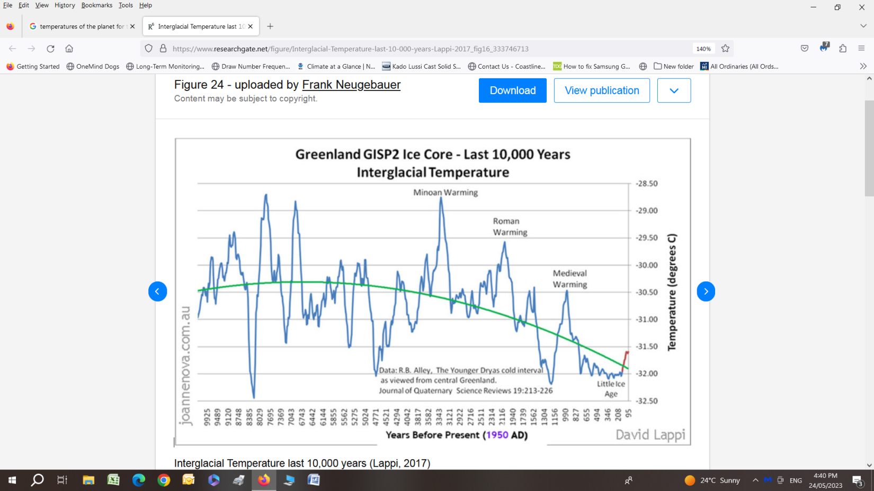
PAGE THIRTEEN ( Check out the multitude of Temp Models compared to Balloon and Satellite Data ..Morons)
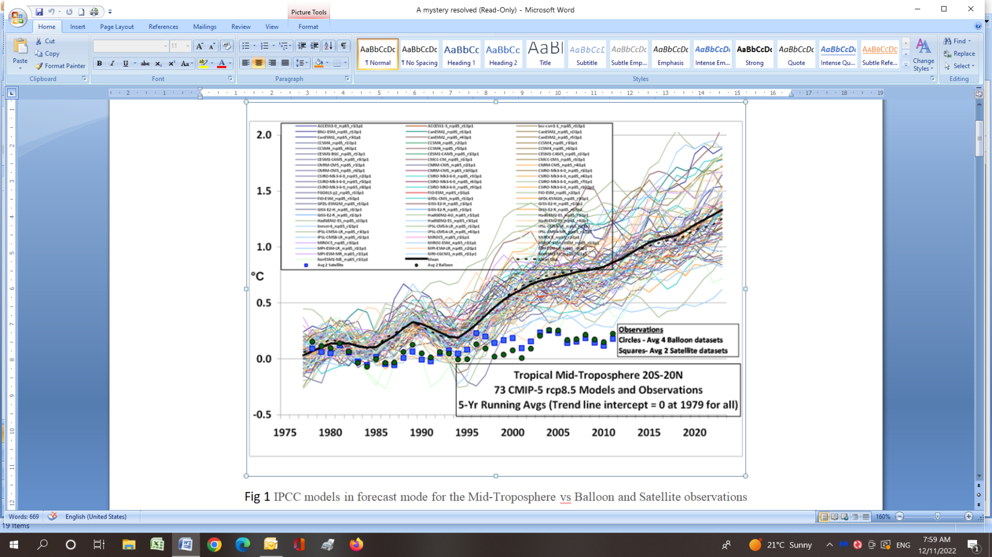
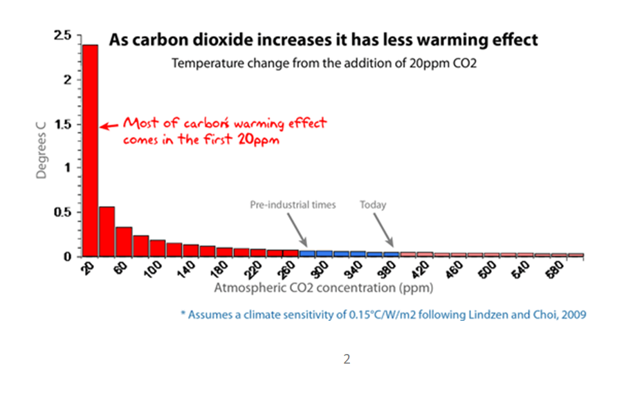
PAGE FOURTEEN
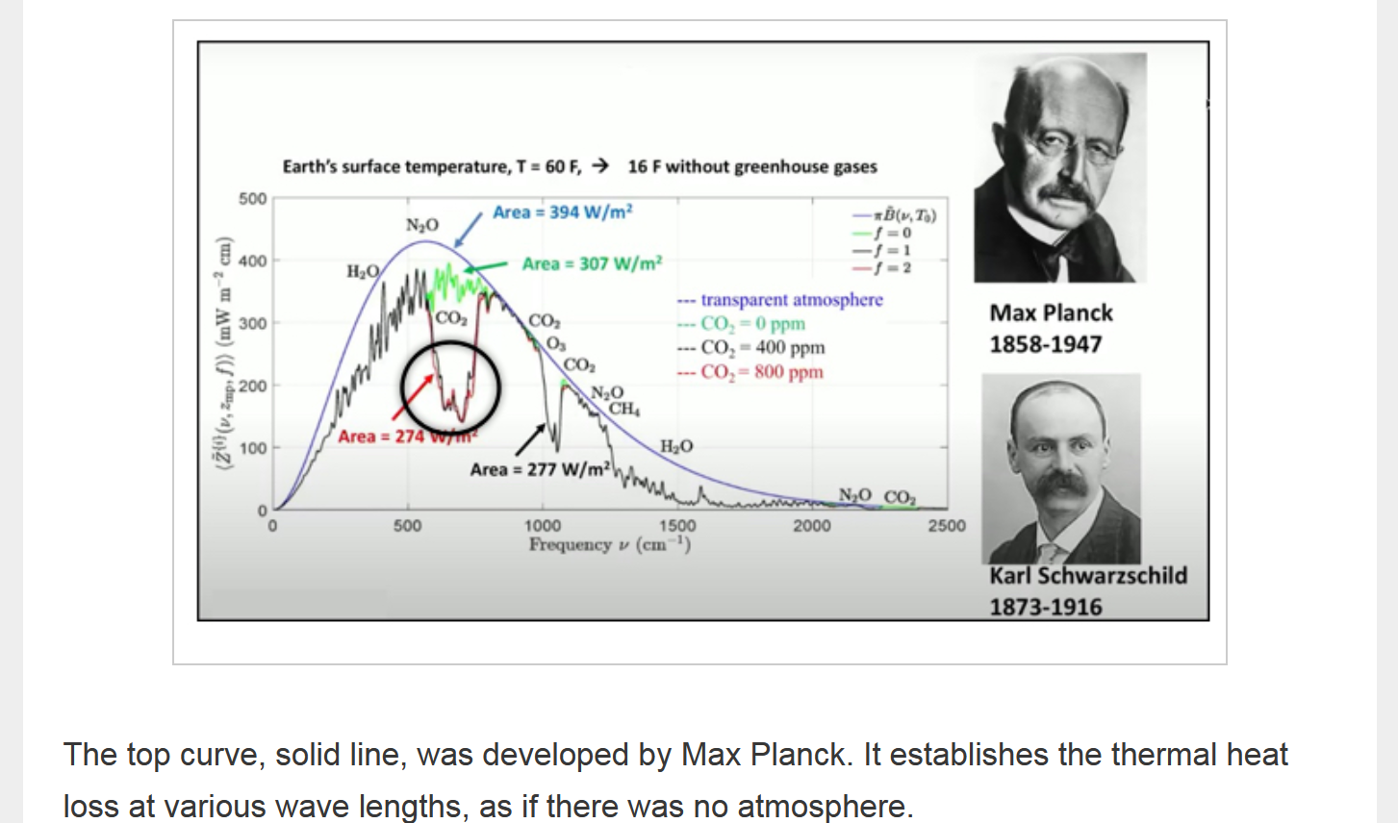
Eighteen years of pretty much no temperature change for the Continental USA fro NOAA
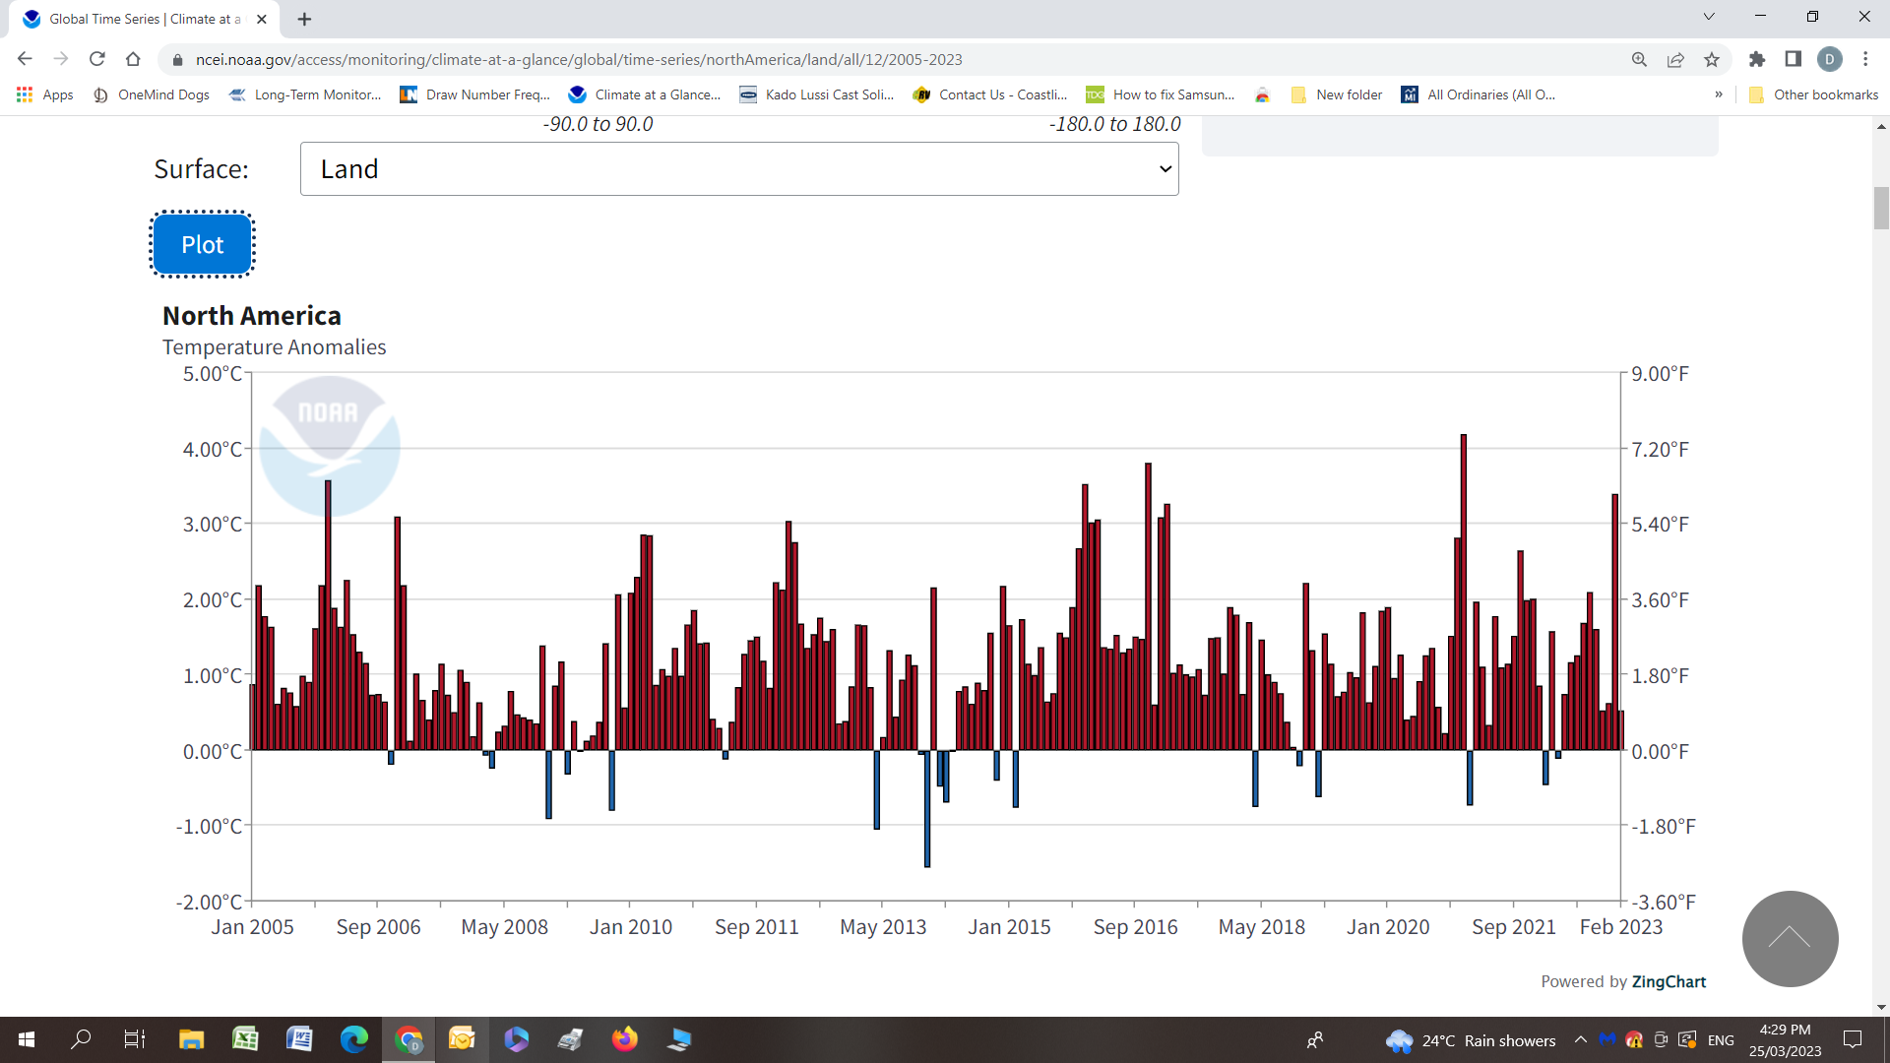

PAGE FIFTEEN Globally , falling temperatures for the past seven years .
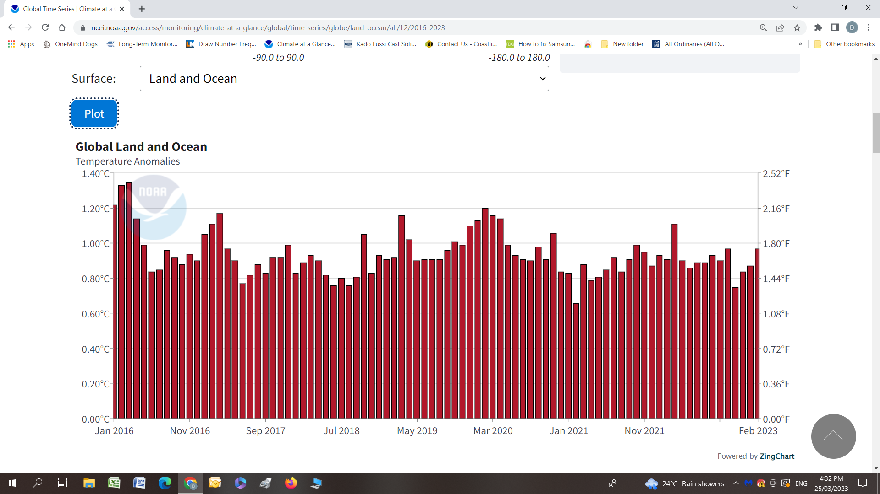
And Australia’s Temperatures falling for 10 years according to the UAH Troposphere Temperature Record .
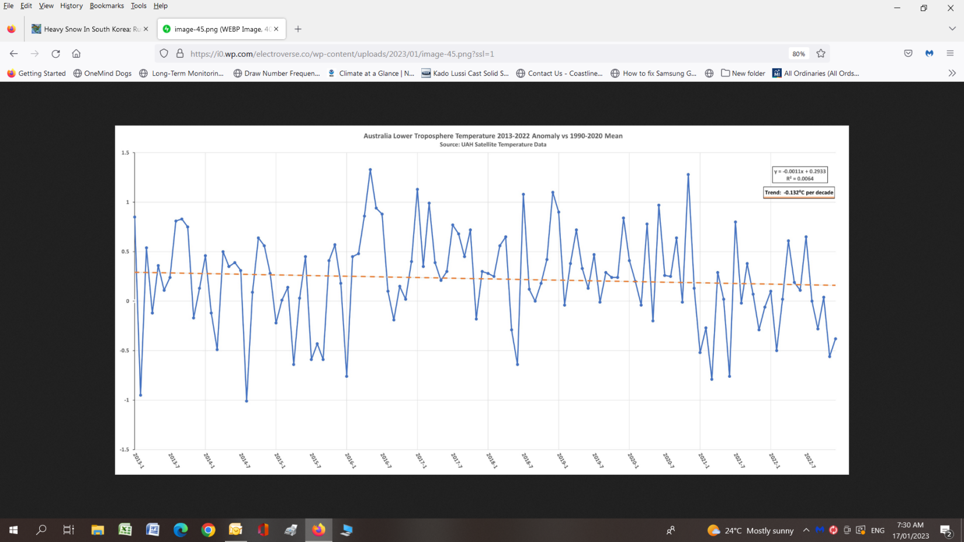

PAGE FIFTEEN
