NUCLEAR ENERGY
Dr D. Weston Allen 8/8/22
- SAFETY
For every unit of power produced, nuclear energy in the U.S. is 4,000 times safer than rooftop solar. Globally it is twice as safe as wind and hundreds of times safer than biomass (wood, crop waste etc).

Source: Conca J. How deadly is your kilowatt? We rank the killer energy sources. Forbes 2012 https://www.forbes.com/sites/jamesconca/2012/06/10/energys-deathprint-a-price-always-paid/#17d1380d709b

- EMISSIONS
Total lifecycle CO₂ emissions for nuclear reactors are comparable to wind and a quarter of PV solar.

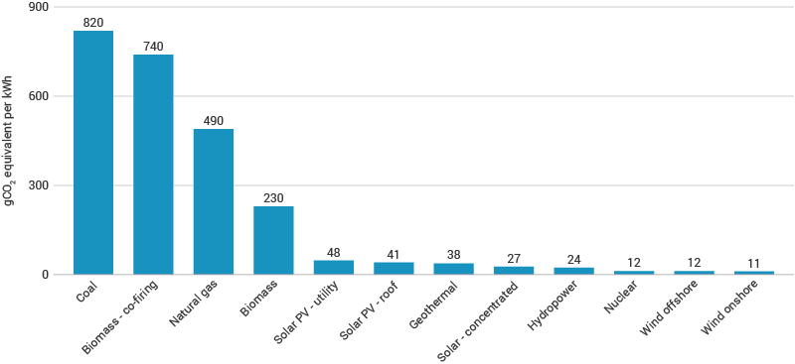
Average lifecycle carbon dioxide-equivalent emissions for different electricity generators (Source: IPCC)
Source: Pehl M, Arvesen A, Humpenöder F. et al. Understanding future emissions from low-carbon power systems by integration of life-cycle assessment and integrated energy modelling. Nat Energy 2017; 2: 939–945
https://doi.org/10.1038/s41560-017-0032-9
- LAND & RESOURCES REQUIRED
Energy output per square kilometer of land used in mining, construction, production & disposal
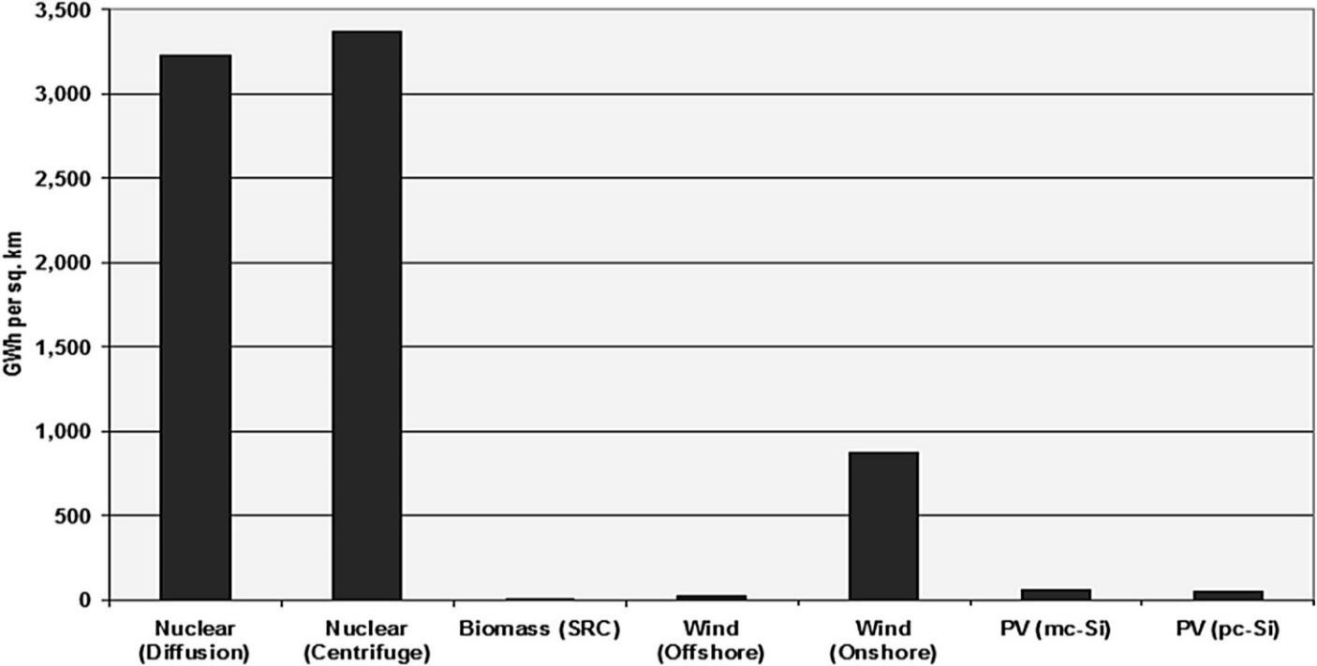
Source: Cheng VKM and Hammond GP. Life-cycle energy densities and land-take requirements of various power generators: a UK perspective. Journal of the Energy Institute 2017; 90 (2): 201-213 https://doi.org/10.1016/j.joei.2016.02.003

Laser enrichment will further enhance such efficiencies as it replaces centrifuge enrichment.

The CSIRO’s Australian National Outlook 2019 proposed allocating 30 million hectares to plantings for carbon credits and over two million hectares for wind and solar farms! These use more concrete than nuclear reactors, in tons per terawatt-hours (TWh) of electricity produced over the life of the energy source, and an order of magnitude more metals:
 | Resources: Lifetime tonnes/TWh | Nuclear | Solar | Wind | Hydro | Gas (load following) | Coal
 | Concrete | 1,060 | 1,220 | 4,470 | 15,320 | 390 | 450
 | Steel | 130 | 940 | 1,450 | 330 | 320 | 160
 | Aluminium | 0.3 | 287.5 | 17.4 | 8.7 | 5.7 | 1.6
 | Copper | 2.5 | 68 | 39.1 | 4.8 | 5.4 | 3
 | Total Metals | 133 | 1,296 | 1,507 | 344 | 331 | 165
 | Glass |  | 2,700 | 92
 | Silicon |  | 57
 | Capacity f. | 85% | 28% | 35% | 50% | 30% | 85%
 | Lifespan yr | 60 | 30 | 30 | 100 | 60 | 60
Source: Mineral requirements for electricity generation (Aug. 2021) https://www.world-nuclear.org/information-library/energy-and-the-environment/mineral-requirements-for-electricity-generation.aspx

- ENERGY OUTPUT / INPUT (ENERGY GAIN RATIO)

Source: Cheng VKM and Hammond GP. Life-cycle energy densities and land-take requirements of various power generators: a UK perspective. Journal of the Energy Institute 2017; 90 (2): 201-213 https://doi.org/10.1016/j.joei.2016.02.003

- CLEANER & GREENER
The mining and refining of materials for resource intensive renewables pollutes the planet with radioactive waste and threatens biodiversity much more than would any mitigated climate change. The PV solar industry, a leading emitter of potent greenhouse gases, creates 300 times more toxic waste per unit of energy produced than does the nuclear industry. Nearly 12,000 wind turbine blades as long as a football field are going to landfill in Europe and the US every year while “All of the used nuclear fuel produced by the U.S. nuclear energy industry over the last 60 years could fit on a football field at a depth of less than 10 yards!” Energy.gov (31/3/21). The safe preparation and storage of nuclear waste is highly regulated. From 2000 to 2019, 13.9 million trees were felled in Scotland alone for wind farms. Globally, they kill countless insects and millions of bats and birds, including endangered raptors, every year.

- TOO EXPENSIVE?
Regions with the most renewables have the highest power prices. Weather-dependent sources cannot provide reliable baseload power, so the expensive infrastructure required for storage greatly increases costs, as do transmission losses of 10-22% for remote sources. Pumped hydro is both expensive and inefficient. Batteries are more efficient but also very expensive, short-lived and fire prone. Hydrogen is hazardous, inefficient, and unproven. Moonbeams must have inspired our PM’s vision of “solar panels on the roof charging your vehicle for free overnight”!
Economics of Nuclear Power states: “Nuclear power is cost competitive with other forms of electricity generation, except where there is direct access to low-cost fossil fuels. . . System costs for nuclear power (as well as coal and gas-fired generation) are very much lower than for intermittent renewables.” Fail-safe Small Modular Reactors (SMRs) offer savings in cost and construction time as well as transmission costs, powering the Australian grid for ~$70/MWh.

- ACHIEVING NET ZERO EMISSIONS
Demand for affordable and reliable energy, the foundation of modern civilization, is expected to grow another 40-60% before the global population peaks mid-century. Wind and solar, which currently provide just 3% of global energy, have no chance of achieving 100% by 2050:
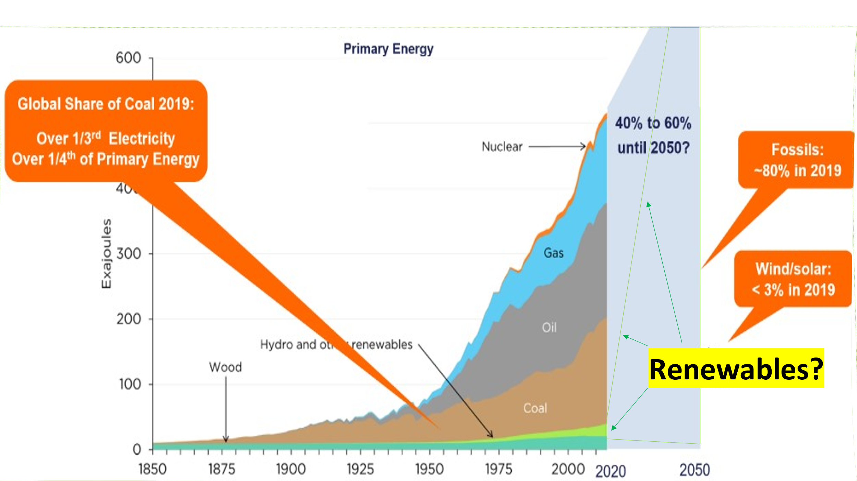
Source: Schernikau Research and Analysis based on data compiled by J. David Hughes. Post-1965 data from BP, Statistical Review of World Energy (link). Pre-1965 data from Arnulf Grubler (1998): “Technology and Global Change: Data Appendix” (link), and World Energy Council (2013): World Energy Scenarios Composing energy futures to 2050 (link).
To achieve net-zero global emissions by 2050 using wind alone, 1,500 turbines (2.5MW each) covering over 750 square kilometres of land would need to be added every day! Solar farms would use even more land.
Could civilization progress or even survive by returning to wood, water, wind, and solar energies?
Not considering nuclear energy now means not considering the planet or its people
Prof Tony Irwin from ANU: The nuclear option | ANU College of Science

